**报告概述：GBRT模型数一共7个，每个模型调整到比较好的状态做了5次交叉验证，本报告包括模型预测偏差的CDF图与特征重要性列表。**

**GBRT参数设置：**

**树棵树：1000**

**树深度：4**

**学习率：0.1**

**损失函数：huber**

**特征选择率：sqrt**

## 模型1

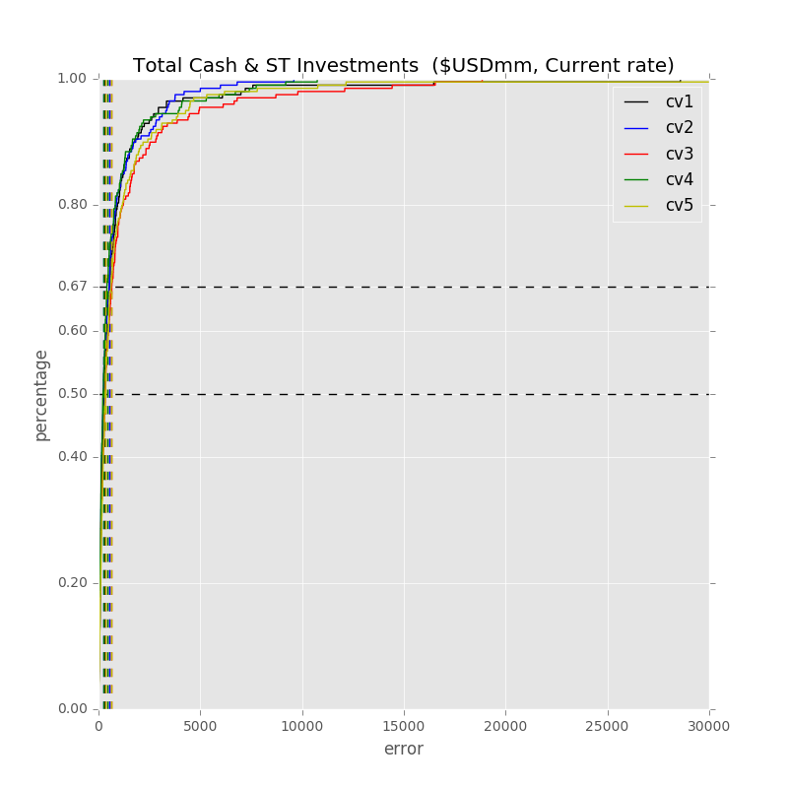

Label: Total Cash & ST Investments ($USDmm, Current rate)

Min Error: 4.120641

Mean Error: 1214.619261

Median Error: 292.632763

Max Error: 64418.394969

Feature importance:

Other Operating Exp. Total ($USDmm, Current rate): 0.038351

EBITDA ($USDmm, Current rate): 0.037784

Rev YOY % : 0.036631

Cash from Ops. ($USDmm, Current rate): 0.036099

Net Income ($USDmm, Current rate): 0.035702

R&D Exp. ($USDmm, Current rate): 0.035073

Total Assets ($USDmm, Current rate): 0.034710

Cash from Ops./Net Income% : 0.034655

Total Asset Turnover : 0.033762

Total Revenue ($USDmm, Current rate): 0.033742

Return on Assets % : 0.033290

Total Liabilities ($USDmm, Current rate): 0.032924

Total Liabilities/Total Assets % : 0.032890

Cash from Ops./EBITDA % : 0.032579

Avg. Days Payable Out. (Days): 0.032454

Net Income Margin % : 0.031752

Net Property, Plant & Equipment ($USDmm, Current rate): 0.031013

Avg. Days Sales Out. (Days): 0.030961

Net Property, Plant & Equipment/ Total Assets % : 0.030959

Depreciation & Amort., Total ($USDmm, Current rate): 0.030956

Gross Margin % : 0.030554

Avg. Cash Conversion Cycle (Days): 0.030473

Return on Equity % : 0.030451

Capital Expenditure ($USDmm, Current rate): 0.029722

Cost Of Goods Sold ($USDmm, Current rate): 0.029312

Total Debt/Equity % : 0.028882

R&D Exp./Total Revenue % : 0.026697

EBITDA Margin % : 0.025953

Avg. Days Inventory Out. (Days): 0.024526

Number of Employees/Total Revenue [LTM] (Latest): 0.020514

Year Founded: 0.018326

Payout Ratio (%): 0.017740

Issuer Credit Rating - Foreign Currency LT [Latest] (Rating): 0.010567

Label: Total Cash & ST Investments ($USDmm, Current rate)

Min Error: 0.088260

Mean Error: 699.446062

Median Error: 236.187817

Max Error: 9595.163311

Feature importance:

Cash from Ops. ($USDmm, Current rate): 0.037404

Net Income ($USDmm, Current rate): 0.037315

Rev YOY % : 0.035937

Avg. Days Payable Out. (Days): 0.035748

Avg. Days Sales Out. (Days): 0.035596

Total Assets ($USDmm, Current rate): 0.035017

Other Operating Exp. Total ($USDmm, Current rate): 0.034819

Net Property, Plant & Equipment/ Total Assets % : 0.033905

EBITDA ($USDmm, Current rate): 0.033443

R&D Exp. ($USDmm, Current rate): 0.033086

Capital Expenditure ($USDmm, Current rate): 0.032866

Cash from Ops./Net Income% : 0.032695

Total Asset Turnover : 0.032692

Total Revenue ($USDmm, Current rate): 0.032577

Total Liabilities ($USDmm, Current rate): 0.032419

EBITDA Margin % : 0.031782

Return on Equity % : 0.031707

Cash from Ops./EBITDA % : 0.031402

Net Property, Plant & Equipment ($USDmm, Current rate): 0.031293

Return on Assets % : 0.030727

Net Income Margin % : 0.030470

Avg. Cash Conversion Cycle (Days): 0.030254

Total Debt/Equity % : 0.029767

Total Liabilities/Total Assets % : 0.029059

Depreciation & Amort., Total ($USDmm, Current rate): 0.028874

Cost Of Goods Sold ($USDmm, Current rate): 0.027420

Avg. Days Inventory Out. (Days): 0.026723

R&D Exp./Total Revenue % : 0.025905

Gross Margin % : 0.025140

Number of Employees/Total Revenue [LTM] (Latest): 0.022343

Year Founded: 0.020642

Payout Ratio (%): 0.018986

Issuer Credit Rating - Foreign Currency LT [Latest] (Rating): 0.011990

Label: Total Cash & ST Investments ($USDmm, Current rate)

Min Error: 3.637670

Mean Error: 1139.530343

Median Error: 336.481795

Max Error: 18847.730070

Feature importance:

Net Income ($USDmm, Current rate): 0.039660

Total Assets ($USDmm, Current rate): 0.038874

Other Operating Exp. Total ($USDmm, Current rate): 0.038506

Cash from Ops. ($USDmm, Current rate): 0.038481

EBITDA ($USDmm, Current rate): 0.035947

Total Revenue ($USDmm, Current rate): 0.034978

Net Property, Plant & Equipment ($USDmm, Current rate): 0.034564

Rev YOY % : 0.033991

Cash from Ops./Net Income% : 0.033672

Avg. Days Sales Out. (Days): 0.033266

Total Liabilities ($USDmm, Current rate): 0.032506

Capital Expenditure ($USDmm, Current rate): 0.032317

Return on Equity % : 0.032138

Cash from Ops./EBITDA % : 0.032037

Avg. Cash Conversion Cycle (Days): 0.031889

Avg. Days Payable Out. (Days): 0.031576

Total Asset Turnover : 0.031540

Depreciation & Amort., Total ($USDmm, Current rate): 0.031510

EBITDA Margin % : 0.031061

Total Liabilities/Total Assets % : 0.030341

Net Income Margin % : 0.030006

R&D Exp. ($USDmm, Current rate): 0.029705

Return on Assets % : 0.028899

Cost Of Goods Sold ($USDmm, Current rate): 0.028347

Net Property, Plant & Equipment/ Total Assets % : 0.027261

Avg. Days Inventory Out. (Days): 0.026607

Gross Margin % : 0.026383

Total Debt/Equity % : 0.026199

R&D Exp./Total Revenue % : 0.025463

Number of Employees/Total Revenue [LTM] (Latest): 0.020880

Year Founded: 0.020772

Payout Ratio (%): 0.020178

Issuer Credit Rating - Foreign Currency LT [Latest] (Rating): 0.010447

Label: Total Cash & ST Investments ($USDmm, Current rate)

Min Error: 1.624394

Mean Error: 737.954598

Median Error: 222.085134

Max Error: 10744.429573

Feature importance:

Net Income ($USDmm, Current rate): 0.041137

Rev YOY % : 0.037186

Other Operating Exp. Total ($USDmm, Current rate): 0.036731

Total Assets ($USDmm, Current rate): 0.036486

Depreciation & Amort., Total ($USDmm, Current rate): 0.035132

Cash from Ops. ($USDmm, Current rate): 0.034663

EBITDA ($USDmm, Current rate): 0.034442

Total Liabilities ($USDmm, Current rate): 0.033003

Return on Assets % : 0.032916

Avg. Days Sales Out. (Days): 0.032658

Avg. Cash Conversion Cycle (Days): 0.032610

Total Asset Turnover : 0.032549

Cash from Ops./Net Income% : 0.032483

Return on Equity % : 0.032025

Total Revenue ($USDmm, Current rate): 0.031648

Avg. Days Payable Out. (Days): 0.031233

Capital Expenditure ($USDmm, Current rate): 0.031111

R&D Exp. ($USDmm, Current rate): 0.030896

EBITDA Margin % : 0.030614

Net Property, Plant & Equipment ($USDmm, Current rate): 0.030203

Total Liabilities/Total Assets % : 0.030043

Net Property, Plant & Equipment/ Total Assets % : 0.029975

Net Income Margin % : 0.029599

Cost Of Goods Sold ($USDmm, Current rate): 0.029385

Cash from Ops./EBITDA % : 0.028846

Total Debt/Equity % : 0.027586

Gross Margin % : 0.027492

Avg. Days Inventory Out. (Days): 0.026785

R&D Exp./Total Revenue % : 0.025972

Number of Employees/Total Revenue [LTM] (Latest): 0.022917

Year Founded: 0.020833

Payout Ratio (%): 0.020030

Issuer Credit Rating - Foreign Currency LT [Latest] (Rating): 0.010811

Label: Total Cash & ST Investments ($USDmm, Current rate)

Min Error: 0.219366

Mean Error: 1125.577128

Median Error: 327.457727

Max Error: 48771.455824

Feature importance:

Rev YOY % : 0.039323

Total Assets ($USDmm, Current rate): 0.037799

Cash from Ops./EBITDA % : 0.037232

Net Income ($USDmm, Current rate): 0.036607

Cash from Ops. ($USDmm, Current rate): 0.036390

Total Liabilities ($USDmm, Current rate): 0.034765

R&D Exp. ($USDmm, Current rate): 0.033861

Other Operating Exp. Total ($USDmm, Current rate): 0.033555

Net Income Margin % : 0.033362

Cash from Ops./Net Income% : 0.033347

EBITDA ($USDmm, Current rate): 0.033335

Net Property, Plant & Equipment/ Total Assets % : 0.033006

Return on Assets % : 0.032923

Avg. Days Payable Out. (Days): 0.032170

Avg. Days Sales Out. (Days): 0.032073

Capital Expenditure ($USDmm, Current rate): 0.031936

Total Revenue ($USDmm, Current rate): 0.031806

Total Asset Turnover : 0.030581

EBITDA Margin % : 0.030306

Gross Margin % : 0.029165

Return on Equity % : 0.028974

Cost Of Goods Sold ($USDmm, Current rate): 0.028662

Net Property, Plant & Equipment ($USDmm, Current rate): 0.028624

Avg. Cash Conversion Cycle (Days): 0.028262

Depreciation & Amort., Total ($USDmm, Current rate): 0.028211

Total Liabilities/Total Assets % : 0.028175

Total Debt/Equity % : 0.028004

R&D Exp./Total Revenue % : 0.026933

Avg. Days Inventory Out. (Days): 0.026028

Number of Employees/Total Revenue [LTM] (Latest): 0.022510

Payout Ratio (%): 0.021954

Year Founded: 0.019891

Issuer Credit Rating - Foreign Currency LT [Latest] (Rating): 0.010233

Total Min: 1.938066

Total Mean: 983.425479

Total Median: 282.969047

Total Max: 30475.434749

## 模型2

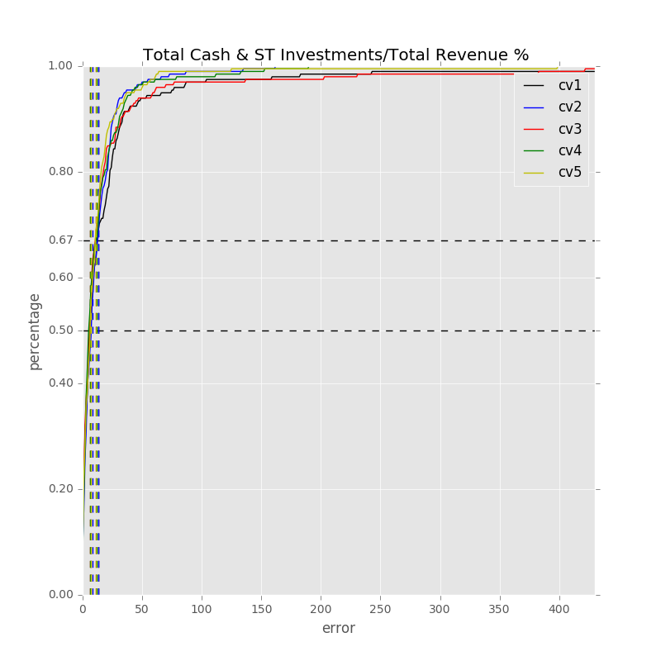

Label: Total Cash & ST Investments/Total Revenue %

Min Error: 0.034179

Mean Error: 30.050492

Median Error: 7.157384

Max Error: 1227.674488

Feature importance:

Rev YOY % : 0.041766

Cash from Ops./Net Income% : 0.041438

Net Income Margin % : 0.039914

Total Liabilities/Total Assets % : 0.037796

EBITDA Margin % : 0.036103

Avg. Days Sales Out. (Days): 0.035052

Net Property, Plant & Equipment/ Total Assets % : 0.034817

Cash from Ops./EBITDA % : 0.034536

Gross Margin % : 0.033727

R&D Exp./Total Revenue % : 0.033521

Other Operating Exp. Total ($USDmm, Current rate): 0.032916

Return on Assets % : 0.032629

Total Asset Turnover : 0.032043

Avg. Cash Conversion Cycle (Days): 0.032030

Depreciation & Amort., Total ($USDmm, Current rate): 0.031419

Total Revenue ($USDmm, Current rate): 0.030543

Total Liabilities ($USDmm, Current rate): 0.030353

Avg. Days Payable Out. (Days): 0.030240

EBITDA ($USDmm, Current rate): 0.030094

Total Debt/Equity % : 0.029458

Cost Of Goods Sold ($USDmm, Current rate): 0.029191

Total Assets ($USDmm, Current rate): 0.028837

Capital Expenditure ($USDmm, Current rate): 0.028267

Cash from Ops. ($USDmm, Current rate): 0.027651

R&D Exp. ($USDmm, Current rate): 0.027479

Return on Equity % : 0.027418

Net Property, Plant & Equipment ($USDmm, Current rate): 0.026428

Net Income ($USDmm, Current rate): 0.026084

Avg. Days Inventory Out. (Days): 0.025905

Number of Employees/Total Revenue [LTM] (Latest): 0.022092

Year Founded: 0.020690

Payout Ratio (%): 0.018458

Issuer Credit Rating - Foreign Currency LT [Latest] (Rating): 0.011107

Label: Total Cash & ST Investments/Total Revenue %

Min Error: 0.008460

Mean Error: 13.295315

Median Error: 8.401931

Max Error: 162.986787

Feature importance:

Rev YOY % : 0.041603

Net Income Margin % : 0.038690

Cash from Ops./Net Income% : 0.038488

Gross Margin % : 0.036817

Total Liabilities/Total Assets % : 0.035723

Return on Assets % : 0.035681

Net Property, Plant & Equipment/ Total Assets % : 0.035282

Cash from Ops./EBITDA % : 0.035135

Total Liabilities ($USDmm, Current rate): 0.033475

R&D Exp./Total Revenue % : 0.033467

Total Revenue ($USDmm, Current rate): 0.033251

Total Asset Turnover : 0.033250

Other Operating Exp. Total ($USDmm, Current rate): 0.032871

Avg. Days Sales Out. (Days): 0.032712

Avg. Days Payable Out. (Days): 0.031402

Cost Of Goods Sold ($USDmm, Current rate): 0.030127

EBITDA Margin % : 0.030013

Total Assets ($USDmm, Current rate): 0.029959

Net Income ($USDmm, Current rate): 0.029772

Avg. Cash Conversion Cycle (Days): 0.029525

R&D Exp. ($USDmm, Current rate): 0.029486

Depreciation & Amort., Total ($USDmm, Current rate): 0.029259

Return on Equity % : 0.028619

Capital Expenditure ($USDmm, Current rate): 0.028309

EBITDA ($USDmm, Current rate): 0.028181

Net Property, Plant & Equipment ($USDmm, Current rate): 0.027503

Cash from Ops. ($USDmm, Current rate): 0.027383

Total Debt/Equity % : 0.026777

Avg. Days Inventory Out. (Days): 0.025420

Number of Employees/Total Revenue [LTM] (Latest): 0.021856

Payout Ratio (%): 0.020130

Year Founded: 0.019945

Issuer Credit Rating - Foreign Currency LT [Latest] (Rating): 0.009889

Label: Total Cash & ST Investments/Total Revenue %

Min Error: 0.005908

Mean Error: 21.907568

Median Error: 6.702507

Max Error: 830.070986

Feature importance:

Total Asset Turnover : 0.037824

Net Income Margin % : 0.037822

Cash from Ops./Net Income% : 0.037542

Rev YOY % : 0.037398

Net Property, Plant & Equipment/ Total Assets % : 0.036987

Cash from Ops./EBITDA % : 0.036189

Gross Margin % : 0.035901

Total Liabilities/Total Assets % : 0.035805

Other Operating Exp. Total ($USDmm, Current rate): 0.035489

Avg. Days Sales Out. (Days): 0.033755

Avg. Cash Conversion Cycle (Days): 0.033096

Return on Assets % : 0.032638

Cost Of Goods Sold ($USDmm, Current rate): 0.031917

Avg. Days Payable Out. (Days): 0.031889

EBITDA Margin % : 0.031849

R&D Exp./Total Revenue % : 0.031212

Total Liabilities ($USDmm, Current rate): 0.031169

Total Revenue ($USDmm, Current rate): 0.031057

Net Income ($USDmm, Current rate): 0.029291

R&D Exp. ($USDmm, Current rate): 0.029223

Capital Expenditure ($USDmm, Current rate): 0.029131

Total Assets ($USDmm, Current rate): 0.029124

Return on Equity % : 0.028958

Depreciation & Amort., Total ($USDmm, Current rate): 0.028265

Avg. Days Inventory Out. (Days): 0.028096

Net Property, Plant & Equipment ($USDmm, Current rate): 0.027592

EBITDA ($USDmm, Current rate): 0.025835

Total Debt/Equity % : 0.025657

Cash from Ops. ($USDmm, Current rate): 0.025282

Year Founded: 0.022928

Number of Employees/Total Revenue [LTM] (Latest): 0.021519

Payout Ratio (%): 0.018678

Issuer Credit Rating - Foreign Currency LT [Latest] (Rating): 0.010884

Label: Total Cash & ST Investments/Total Revenue %

Min Error: 0.071883

Mean Error: 13.711832

Median Error: 6.181146

Max Error: 190.226493

Feature importance:

Rev YOY % : 0.041258

Cash from Ops./Net Income% : 0.039515

Net Property, Plant & Equipment/ Total Assets % : 0.038011

Cash from Ops./EBITDA % : 0.037897

Total Asset Turnover : 0.036362

R&D Exp./Total Revenue % : 0.035212

Net Income Margin % : 0.034890

Total Liabilities/Total Assets % : 0.034787

Gross Margin % : 0.034672

Return on Assets % : 0.033841

Total Liabilities ($USDmm, Current rate): 0.033688

Avg. Days Sales Out. (Days): 0.032822

Avg. Cash Conversion Cycle (Days): 0.032676

Avg. Days Payable Out. (Days): 0.032614

Net Income ($USDmm, Current rate): 0.032060

EBITDA ($USDmm, Current rate): 0.031281

EBITDA Margin % : 0.031248

Capital Expenditure ($USDmm, Current rate): 0.031157

Other Operating Exp. Total ($USDmm, Current rate): 0.030352

Cost Of Goods Sold ($USDmm, Current rate): 0.030067

Return on Equity % : 0.029972

Depreciation & Amort., Total ($USDmm, Current rate): 0.028479

Total Revenue ($USDmm, Current rate): 0.028381

Avg. Days Inventory Out. (Days): 0.028078

Net Property, Plant & Equipment ($USDmm, Current rate): 0.027749

Cash from Ops. ($USDmm, Current rate): 0.027712

Total Assets ($USDmm, Current rate): 0.026849

Total Debt/Equity % : 0.025520

R&D Exp. ($USDmm, Current rate): 0.024689

Payout Ratio (%): 0.020672

Number of Employees/Total Revenue [LTM] (Latest): 0.018765

Year Founded: 0.018229

Issuer Credit Rating - Foreign Currency LT [Latest] (Rating): 0.010494

Label: Total Cash & ST Investments/Total Revenue %

Min Error: 0.070550

Mean Error: 13.397328

Median Error: 7.373592

Max Error: 399.418686

Feature importance:

Rev YOY % : 0.039904

Cash from Ops./Net Income% : 0.037291

Cash from Ops./EBITDA % : 0.036628

Total Liabilities/Total Assets % : 0.036450

Net Income Margin % : 0.036342

Return on Assets % : 0.035895

Total Asset Turnover : 0.035852

R&D Exp./Total Revenue % : 0.034622

Gross Margin % : 0.034187

Avg. Cash Conversion Cycle (Days): 0.033708

Avg. Days Sales Out. (Days): 0.033356

Net Property, Plant & Equipment/ Total Assets % : 0.031720

Other Operating Exp. Total ($USDmm, Current rate): 0.031511

Return on Equity % : 0.031484

EBITDA Margin % : 0.031115

Total Liabilities ($USDmm, Current rate): 0.030898

Avg. Days Payable Out. (Days): 0.030476

Net Property, Plant & Equipment ($USDmm, Current rate): 0.030250

Depreciation & Amort., Total ($USDmm, Current rate): 0.030093

Net Income ($USDmm, Current rate): 0.029854

Cost Of Goods Sold ($USDmm, Current rate): 0.029707

EBITDA ($USDmm, Current rate): 0.029155

Total Assets ($USDmm, Current rate): 0.028473

Capital Expenditure ($USDmm, Current rate): 0.028412

Total Revenue ($USDmm, Current rate): 0.028218

R&D Exp. ($USDmm, Current rate): 0.028083

Cash from Ops. ($USDmm, Current rate): 0.027859

Total Debt/Equity % : 0.027677

Avg. Days Inventory Out. (Days): 0.026720

Number of Employees/Total Revenue [LTM] (Latest): 0.023018

Year Founded: 0.021332

Payout Ratio (%): 0.018470

Issuer Credit Rating - Foreign Currency LT [Latest] (Rating): 0.011239

Total Min: 0.038196

Total Mean: 18.472507

Total Median: 7.163312

Total Max: 562.075488

## 模型3

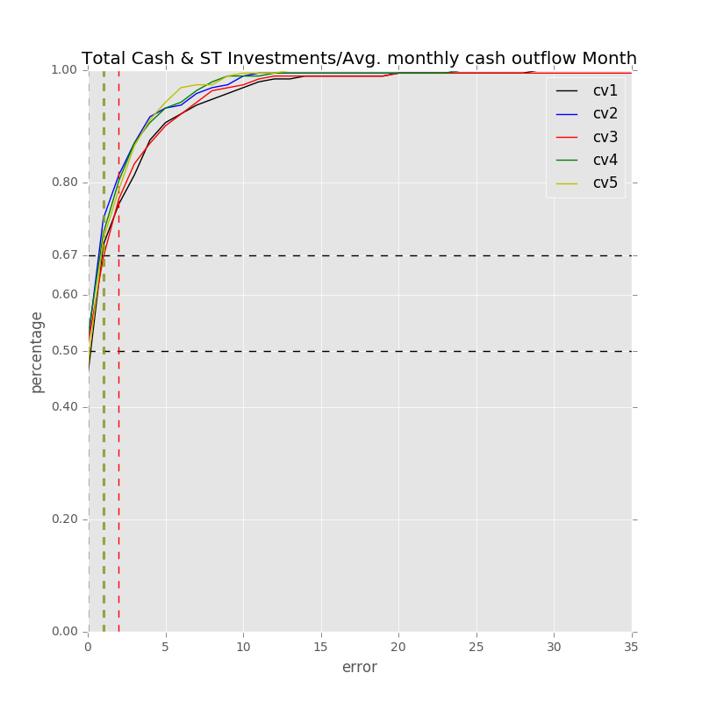

Label: Total Cash & ST Investments/Avg. monthly cash outflow Month

Min Error: 0.003901

Mean Error: 2.381600

Median Error: 1.211584

Max Error: 29.847566

Feature importance:

Net Income Margin % : 0.039304

Rev YOY % : 0.038719

Avg. Days Sales Out. (Days): 0.037601

Cash from Ops./Net Income% : 0.037512

Total Liabilities/Total Assets % : 0.037155

EBITDA Margin % : 0.036862

Total Asset Turnover : 0.036180

Cash from Ops./EBITDA % : 0.035485

Return on Assets % : 0.034994

Gross Margin % : 0.034844

Avg. Cash Conversion Cycle (Days): 0.033070

Net Income ($USDmm, Current rate): 0.032648

Net Property, Plant & Equipment/ Total Assets % : 0.032513

Total Liabilities ($USDmm, Current rate): 0.031570

Cost Of Goods Sold ($USDmm, Current rate): 0.031399

R&D Exp./Total Revenue % : 0.030732

Avg. Days Payable Out. (Days): 0.030582

Return on Equity % : 0.030508

Depreciation & Amort., Total ($USDmm, Current rate): 0.029966

Other Operating Exp. Total ($USDmm, Current rate): 0.029498

Total Revenue ($USDmm, Current rate): 0.029452

Total Assets ($USDmm, Current rate): 0.029113

Cash from Ops. ($USDmm, Current rate): 0.028007

R&D Exp. ($USDmm, Current rate): 0.027511

EBITDA ($USDmm, Current rate): 0.027353

Capital Expenditure ($USDmm, Current rate): 0.027039

Total Debt/Equity % : 0.026626

Avg. Days Inventory Out. (Days): 0.025647

Net Property, Plant & Equipment ($USDmm, Current rate): 0.024701

Year Founded: 0.021274

Number of Employees/Total Revenue [LTM] (Latest): 0.020590

Payout Ratio (%): 0.020171

Issuer Credit Rating - Foreign Currency LT [Latest] (Rating): 0.011370

Label: Total Cash & ST Investments/Avg. monthly cash outflow Month

Min Error: 0.010061

Mean Error: 1.901892

Median Error: 0.916848

Max Error: 24.912025

Feature importance:

Rev YOY % : 0.039974

Return on Assets % : 0.037983

Net Income Margin % : 0.037714

Total Asset Turnover : 0.036634

Cash from Ops./EBITDA % : 0.036506

Total Liabilities/Total Assets % : 0.036269

Gross Margin % : 0.036236

EBITDA Margin % : 0.036195

Cash from Ops./Net Income% : 0.034892

Net Property, Plant & Equipment/ Total Assets % : 0.032031

Avg. Cash Conversion Cycle (Days): 0.031841

Avg. Days Payable Out. (Days): 0.031734

Avg. Days Sales Out. (Days): 0.031674

R&D Exp./Total Revenue % : 0.031366

Depreciation & Amort., Total ($USDmm, Current rate): 0.030472

Capital Expenditure ($USDmm, Current rate): 0.030117

Total Revenue ($USDmm, Current rate): 0.029987

Other Operating Exp. Total ($USDmm, Current rate): 0.029754

Total Liabilities ($USDmm, Current rate): 0.029549

Cash from Ops. ($USDmm, Current rate): 0.029482

Return on Equity % : 0.028963

EBITDA ($USDmm, Current rate): 0.028738

Net Income ($USDmm, Current rate): 0.028539

R&D Exp. ($USDmm, Current rate): 0.028447

Cost Of Goods Sold ($USDmm, Current rate): 0.028233

Avg. Days Inventory Out. (Days): 0.027967

Total Assets ($USDmm, Current rate): 0.027271

Total Debt/Equity % : 0.027234

Net Property, Plant & Equipment ($USDmm, Current rate): 0.026636

Year Founded: 0.024107

Number of Employees/Total Revenue [LTM] (Latest): 0.023037

Payout Ratio (%): 0.015710

Issuer Credit Rating - Foreign Currency LT [Latest] (Rating): 0.014708

Label: Total Cash & ST Investments/Avg. monthly cash outflow Month

Min Error: 0.022939

Mean Error: 2.588481

Median Error: 0.987865

Max Error: 45.973829

Feature importance:

Net Income Margin % : 0.039772

Rev YOY % : 0.039728

Cash from Ops./EBITDA % : 0.035919

Cash from Ops./Net Income% : 0.034999

Total Asset Turnover : 0.034627

Gross Margin % : 0.034313

Total Liabilities/Total Assets % : 0.033997

Other Operating Exp. Total ($USDmm, Current rate): 0.033930

Return on Equity % : 0.033769

Net Property, Plant & Equipment/ Total Assets % : 0.033655

Depreciation & Amort., Total ($USDmm, Current rate): 0.033128

EBITDA Margin % : 0.032737

R&D Exp./Total Revenue % : 0.032349

Return on Assets % : 0.032011

Total Liabilities ($USDmm, Current rate): 0.031470

Capital Expenditure ($USDmm, Current rate): 0.031418

Avg. Cash Conversion Cycle (Days): 0.031251

Avg. Days Sales Out. (Days): 0.031081

Avg. Days Payable Out. (Days): 0.030325

Cost Of Goods Sold ($USDmm, Current rate): 0.030147

Total Revenue ($USDmm, Current rate): 0.029645

Cash from Ops. ($USDmm, Current rate): 0.028743

Net Property, Plant & Equipment ($USDmm, Current rate): 0.028705

EBITDA ($USDmm, Current rate): 0.028468

Total Assets ($USDmm, Current rate): 0.028402

Net Income ($USDmm, Current rate): 0.027826

Total Debt/Equity % : 0.027806

Avg. Days Inventory Out. (Days): 0.027597

R&D Exp. ($USDmm, Current rate): 0.025769

Year Founded: 0.022958

Payout Ratio (%): 0.020821

Number of Employees/Total Revenue [LTM] (Latest): 0.019625

Issuer Credit Rating - Foreign Currency LT [Latest] (Rating): 0.013010

Label: Total Cash & ST Investments/Avg. monthly cash outflow Month

Min Error: 0.008327

Mean Error: 1.897665

Median Error: 0.896095

Max Error: 24.283646

Feature importance:

Net Income Margin % : 0.042392

Rev YOY % : 0.041447

Cash from Ops./Net Income% : 0.039063

Cash from Ops./EBITDA % : 0.038536

Gross Margin % : 0.038066

Avg. Cash Conversion Cycle (Days): 0.035607

Avg. Days Sales Out. (Days): 0.035572

Return on Assets % : 0.035445

Total Asset Turnover : 0.034015

EBITDA Margin % : 0.033439

Net Property, Plant & Equipment/ Total Assets % : 0.033000

Net Income ($USDmm, Current rate): 0.032843

Total Liabilities/Total Assets % : 0.032370

Return on Equity % : 0.032239

R&D Exp./Total Revenue % : 0.031364

Avg. Days Payable Out. (Days): 0.031021

Total Liabilities ($USDmm, Current rate): 0.030823

Depreciation & Amort., Total ($USDmm, Current rate): 0.029449

Cost Of Goods Sold ($USDmm, Current rate): 0.029164

Other Operating Exp. Total ($USDmm, Current rate): 0.029040

Total Assets ($USDmm, Current rate): 0.028020

EBITDA ($USDmm, Current rate): 0.028004

Net Property, Plant & Equipment ($USDmm, Current rate): 0.027131

Total Revenue ($USDmm, Current rate): 0.027057

Avg. Days Inventory Out. (Days): 0.026899

Total Debt/Equity % : 0.025659

Capital Expenditure ($USDmm, Current rate): 0.025136

Number of Employees/Total Revenue [LTM] (Latest): 0.024616

R&D Exp. ($USDmm, Current rate): 0.024588

Year Founded: 0.023610

Cash from Ops. ($USDmm, Current rate): 0.023089

Payout Ratio (%): 0.019001

Issuer Credit Rating - Foreign Currency LT [Latest] (Rating): 0.012295

Label: Total Cash & ST Investments/Avg. monthly cash outflow Month

Min Error: 0.000347

Mean Error: 1.886802

Median Error: 1.059769

Max Error: 13.112348

Feature importance:

Net Income Margin % : 0.041165

Rev YOY % : 0.040743

Cash from Ops./Net Income% : 0.038508

Gross Margin % : 0.038209

Return on Assets % : 0.036545

Avg. Cash Conversion Cycle (Days): 0.034811

EBITDA Margin % : 0.034735

Total Asset Turnover : 0.034693

Total Liabilities/Total Assets % : 0.034576

Capital Expenditure ($USDmm, Current rate): 0.034433

Cash from Ops./EBITDA % : 0.033266

R&D Exp./Total Revenue % : 0.032305

Avg. Days Sales Out. (Days): 0.032080

Total Liabilities ($USDmm, Current rate): 0.031957

Other Operating Exp. Total ($USDmm, Current rate): 0.031813

Total Assets ($USDmm, Current rate): 0.030434

Depreciation & Amort., Total ($USDmm, Current rate): 0.029781

Return on Equity % : 0.029774

Cost Of Goods Sold ($USDmm, Current rate): 0.029339

Avg. Days Payable Out. (Days): 0.028628

Total Revenue ($USDmm, Current rate): 0.028422

Net Property, Plant & Equipment/ Total Assets % : 0.028376

Avg. Days Inventory Out. (Days): 0.028301

Cash from Ops. ($USDmm, Current rate): 0.027929

Total Debt/Equity % : 0.027675

Net Property, Plant & Equipment ($USDmm, Current rate): 0.027618

Net Income ($USDmm, Current rate): 0.027480

EBITDA ($USDmm, Current rate): 0.027089

R&D Exp. ($USDmm, Current rate): 0.025637

Year Founded: 0.020089

Number of Employees/Total Revenue [LTM] (Latest): 0.019786

Payout Ratio (%): 0.019641

Issuer Credit Rating - Foreign Currency LT [Latest] (Rating): 0.014162

Total Min: 0.009115

Total Mean: 2.131288

Total Median: 1.014432

Total Max: 27.625882

## 模型4

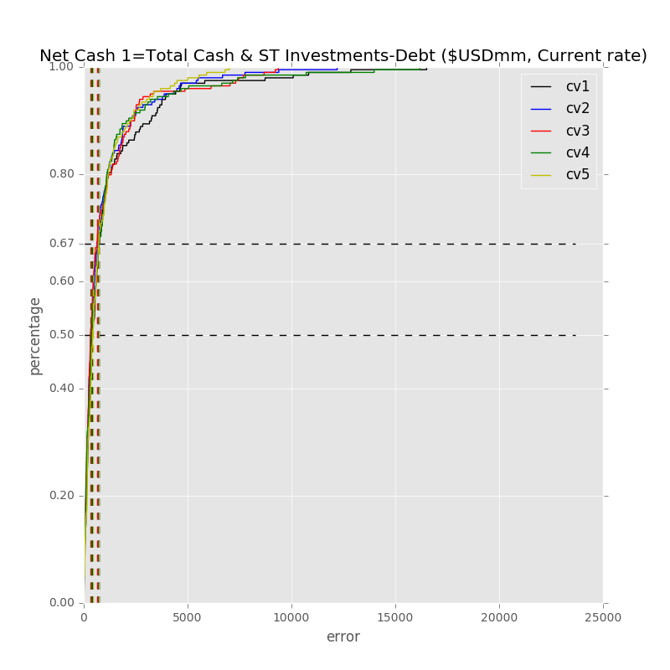

Label: Net Cash 1=Total Cash & ST Investments-Debt ($USDmm, Current rate)

Min Error: 3.117358

Mean Error: 1226.994827

Median Error: 404.884861

Max Error: 23671.894944

Feature importance:

Cash from Ops./Net Income% : 0.037566

Other Operating Exp. Total ($USDmm, Current rate): 0.037102

EBITDA ($USDmm, Current rate): 0.036043

Rev YOY % : 0.035912

Total Asset Turnover : 0.035382

Net Income ($USDmm, Current rate): 0.035239

Avg. Days Sales Out. (Days): 0.034239

Net Income Margin % : 0.034030

Total Liabilities/Total Assets % : 0.033850

Total Liabilities ($USDmm, Current rate): 0.033415

Total Assets ($USDmm, Current rate): 0.032716

Capital Expenditure ($USDmm, Current rate): 0.032036

Gross Margin % : 0.031904

Return on Assets % : 0.031880

Total Debt/Equity % : 0.031847

Net Property, Plant & Equipment ($USDmm, Current rate): 0.031520

Cash from Ops./EBITDA % : 0.031100

Cash from Ops. ($USDmm, Current rate): 0.030923

EBITDA Margin % : 0.030691

Return on Equity % : 0.030546

Net Property, Plant & Equipment/ Total Assets % : 0.030247

Avg. Cash Conversion Cycle (Days): 0.030195

Total Revenue ($USDmm, Current rate): 0.029035

R&D Exp. ($USDmm, Current rate): 0.028765

Depreciation & Amort., Total ($USDmm, Current rate): 0.028721

Avg. Days Payable Out. (Days): 0.027948

Cost Of Goods Sold ($USDmm, Current rate): 0.027029

Avg. Days Inventory Out. (Days): 0.025466

Number of Employees/Total Revenue [LTM] (Latest): 0.024899

Year Founded: 0.023924

R&D Exp./Total Revenue % : 0.023599

Payout Ratio (%): 0.021016

Issuer Credit Rating - Foreign Currency LT [Latest] (Rating): 0.011216

Label: Net Cash 1=Total Cash & ST Investments-Debt ($USDmm, Current rate)

Min Error: 0.001120

Mean Error: 906.996478

Median Error: 348.632774

Max Error: 12201.120493

Feature importance:

Rev YOY % : 0.038509

Cash from Ops./Net Income% : 0.036449

Total Liabilities/Total Assets % : 0.035264

Total Assets ($USDmm, Current rate): 0.034533

Net Property, Plant & Equipment/ Total Assets % : 0.034491

EBITDA ($USDmm, Current rate): 0.034371

Capital Expenditure ($USDmm, Current rate): 0.034342

Avg. Days Sales Out. (Days): 0.034279

Total Debt/Equity % : 0.034159

Net Income Margin % : 0.034132

Total Revenue ($USDmm, Current rate): 0.033770

Net Income ($USDmm, Current rate): 0.033683

Cash from Ops. ($USDmm, Current rate): 0.032936

Net Property, Plant & Equipment ($USDmm, Current rate): 0.032812

Total Liabilities ($USDmm, Current rate): 0.032165

Cash from Ops./EBITDA % : 0.031964

Total Asset Turnover : 0.031672

Other Operating Exp. Total ($USDmm, Current rate): 0.031649

Avg. Days Payable Out. (Days): 0.031262

Cost Of Goods Sold ($USDmm, Current rate): 0.030602

Avg. Cash Conversion Cycle (Days): 0.030329

Gross Margin % : 0.029456

R&D Exp. ($USDmm, Current rate): 0.029394

Return on Assets % : 0.029043

Return on Equity % : 0.028640

Depreciation & Amort., Total ($USDmm, Current rate): 0.028544

EBITDA Margin % : 0.026995

Avg. Days Inventory Out. (Days): 0.026639

R&D Exp./Total Revenue % : 0.023425

Year Founded: 0.022073

Payout Ratio (%): 0.021141

Number of Employees/Total Revenue [LTM] (Latest): 0.020121

Issuer Credit Rating - Foreign Currency LT [Latest] (Rating): 0.011155

Label: Net Cash 1=Total Cash & ST Investments-Debt ($USDmm, Current rate)

Min Error: 1.210681

Mean Error: 932.109856

Median Error: 319.176363

Max Error: 9363.112159

Feature importance:

Rev YOY % : 0.040557

Cash from Ops./EBITDA % : 0.038506

Net Income ($USDmm, Current rate): 0.036939

Total Liabilities/Total Assets % : 0.036603

Avg. Days Payable Out. (Days): 0.035099

Cash from Ops./Net Income% : 0.034416

Total Assets ($USDmm, Current rate): 0.033920

Capital Expenditure ($USDmm, Current rate): 0.033874

Cash from Ops. ($USDmm, Current rate): 0.033815

Total Asset Turnover : 0.033595

EBITDA ($USDmm, Current rate): 0.033084

Avg. Cash Conversion Cycle (Days): 0.032617

Return on Assets % : 0.032381

Net Property, Plant & Equipment/ Total Assets % : 0.031936

Return on Equity % : 0.031881

Avg. Days Sales Out. (Days): 0.031758

Avg. Days Inventory Out. (Days): 0.031451

Net Property, Plant & Equipment ($USDmm, Current rate): 0.031316

Total Debt/Equity % : 0.031160

Other Operating Exp. Total ($USDmm, Current rate): 0.030595

Total Liabilities ($USDmm, Current rate): 0.030159

Net Income Margin % : 0.029364

Gross Margin % : 0.028748

R&D Exp. ($USDmm, Current rate): 0.028565

Cost Of Goods Sold ($USDmm, Current rate): 0.027972

Depreciation & Amort., Total ($USDmm, Current rate): 0.027912

EBITDA Margin % : 0.027746

Total Revenue ($USDmm, Current rate): 0.026698

Number of Employees/Total Revenue [LTM] (Latest): 0.022917

Payout Ratio (%): 0.021542

Year Founded: 0.021445

R&D Exp./Total Revenue % : 0.020422

Issuer Credit Rating - Foreign Currency LT [Latest] (Rating): 0.011003

Label: Net Cash 1=Total Cash & ST Investments-Debt ($USDmm, Current rate)

Min Error: 0.887190

Mean Error: 1012.122217

Median Error: 381.001411

Max Error: 16176.480187

Feature importance:

Net Income ($USDmm, Current rate): 0.039046

Other Operating Exp. Total ($USDmm, Current rate): 0.036895

Cash from Ops. ($USDmm, Current rate): 0.035140

Total Liabilities/Total Assets % : 0.034993

Cash from Ops./EBITDA % : 0.034436

Total Debt/Equity % : 0.033787

Avg. Days Sales Out. (Days): 0.033666

Rev YOY % : 0.033395

Cash from Ops./Net Income% : 0.033334

Total Asset Turnover : 0.033247

Total Revenue ($USDmm, Current rate): 0.033047

Avg. Days Payable Out. (Days): 0.032983

Total Liabilities ($USDmm, Current rate): 0.032899

Capital Expenditure ($USDmm, Current rate): 0.032490

Net Property, Plant & Equipment/ Total Assets % : 0.032486

Avg. Cash Conversion Cycle (Days): 0.032429

Total Assets ($USDmm, Current rate): 0.032307

Return on Assets % : 0.031874

Return on Equity % : 0.031769

Net Property, Plant & Equipment ($USDmm, Current rate): 0.031729

Gross Margin % : 0.029435

Net Income Margin % : 0.029388

Depreciation & Amort., Total ($USDmm, Current rate): 0.028711

EBITDA ($USDmm, Current rate): 0.028625

Avg. Days Inventory Out. (Days): 0.028497

EBITDA Margin % : 0.026991

R&D Exp. ($USDmm, Current rate): 0.026603

Cost Of Goods Sold ($USDmm, Current rate): 0.026591

R&D Exp./Total Revenue % : 0.023996

Number of Employees/Total Revenue [LTM] (Latest): 0.023523

Year Founded: 0.023225

Payout Ratio (%): 0.020120

Issuer Credit Rating - Foreign Currency LT [Latest] (Rating): 0.012340

Label: Net Cash 1=Total Cash & ST Investments-Debt ($USDmm, Current rate)

Min Error: 3.982258

Mean Error: 865.652372

Median Error: 431.963359

Max Error: 7015.661014

Feature importance:

Net Income ($USDmm, Current rate): 0.036152

EBITDA ($USDmm, Current rate): 0.035599

Other Operating Exp. Total ($USDmm, Current rate): 0.034826

Rev YOY % : 0.034729

Total Asset Turnover : 0.034510

Capital Expenditure ($USDmm, Current rate): 0.034383

Cash from Ops. ($USDmm, Current rate): 0.034091

Cash from Ops./Net Income% : 0.034077

Cash from Ops./EBITDA % : 0.033937

Return on Assets % : 0.033855

Total Revenue ($USDmm, Current rate): 0.033536

Total Liabilities/Total Assets % : 0.033313

Avg. Cash Conversion Cycle (Days): 0.033216

Total Assets ($USDmm, Current rate): 0.032993

Avg. Days Sales Out. (Days): 0.032963

Net Property, Plant & Equipment/ Total Assets % : 0.032940

Total Debt/Equity % : 0.032123

Avg. Days Payable Out. (Days): 0.031774

R&D Exp. ($USDmm, Current rate): 0.031662

Net Income Margin % : 0.031434

Total Liabilities ($USDmm, Current rate): 0.030530

Net Property, Plant & Equipment ($USDmm, Current rate): 0.030321

Gross Margin % : 0.029253

Avg. Days Inventory Out. (Days): 0.028660

Cost Of Goods Sold ($USDmm, Current rate): 0.027894

Depreciation & Amort., Total ($USDmm, Current rate): 0.027792

EBITDA Margin % : 0.027501

Return on Equity % : 0.026404

R&D Exp./Total Revenue % : 0.024979

Number of Employees/Total Revenue [LTM] (Latest): 0.023385

Payout Ratio (%): 0.021853

Year Founded: 0.019725

Issuer Credit Rating - Foreign Currency LT [Latest] (Rating): 0.009587

Total Min: 1.839721

Total Mean: 988.775150

Total Median: 377.131754

Total Max: 13685.653759

## 模型5

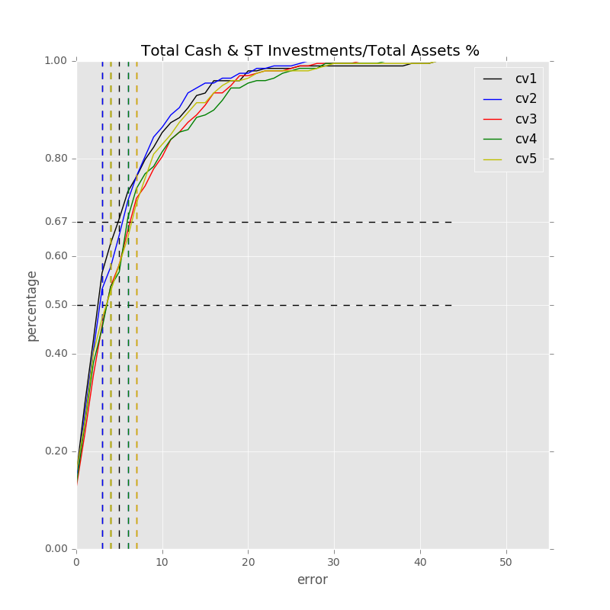

Label: Total Cash & ST Investments/Total Assets %

Min Error: 0.048137

Mean Error: 5.872522

Median Error: 3.467924

Max Error: 44.136655

Feature importance:

Rev YOY % : 0.040511

Cash from Ops./EBITDA % : 0.037734

Return on Assets % : 0.037256

Cash from Ops./Net Income% : 0.036817

Net Property, Plant & Equipment/ Total Assets % : 0.035529

Total Liabilities ($USDmm, Current rate): 0.033906

Total Assets ($USDmm, Current rate): 0.033845

Total Liabilities/Total Assets % : 0.033058

Avg. Days Sales Out. (Days): 0.032830

Avg. Cash Conversion Cycle (Days): 0.032581

Total Asset Turnover : 0.032542

Net Income Margin % : 0.032377

Other Operating Exp. Total ($USDmm, Current rate): 0.032270

Gross Margin % : 0.032096

Capital Expenditure ($USDmm, Current rate): 0.031979

Avg. Days Payable Out. (Days): 0.030855

EBITDA ($USDmm, Current rate): 0.030431

EBITDA Margin % : 0.030277

R&D Exp./Total Revenue % : 0.029696

Return on Equity % : 0.029189

Avg. Days Inventory Out. (Days): 0.029108

Total Revenue ($USDmm, Current rate): 0.028788

Cash from Ops. ($USDmm, Current rate): 0.028614

Depreciation & Amort., Total ($USDmm, Current rate): 0.028384

Net Income ($USDmm, Current rate): 0.028231

Cost Of Goods Sold ($USDmm, Current rate): 0.028211

Net Property, Plant & Equipment ($USDmm, Current rate): 0.027165

R&D Exp. ($USDmm, Current rate): 0.026859

Total Debt/Equity % : 0.026721

Number of Employees/Total Revenue [LTM] (Latest): 0.026631

Year Founded: 0.023185

Payout Ratio (%): 0.017466

Issuer Credit Rating - Foreign Currency LT [Latest] (Rating): 0.014859

Label: Total Cash & ST Investments/Total Assets %

Min Error: 0.010467

Mean Error: 5.514010

Median Error: 3.605869

Max Error: 27.188138

Feature importance:

Return on Assets % : 0.038938

Cash from Ops./EBITDA % : 0.038229

Cash from Ops./Net Income% : 0.035181

Net Income Margin % : 0.034797

Rev YOY % : 0.034678

Total Liabilities/Total Assets % : 0.034666

Other Operating Exp. Total ($USDmm, Current rate): 0.034539

Avg. Days Sales Out. (Days): 0.034024

Avg. Cash Conversion Cycle (Days): 0.033894

EBITDA Margin % : 0.033674

Net Property, Plant & Equipment/ Total Assets % : 0.032703

Total Asset Turnover : 0.032132

Return on Equity % : 0.032095

Total Assets ($USDmm, Current rate): 0.031964

Net Income ($USDmm, Current rate): 0.031468

Total Revenue ($USDmm, Current rate): 0.031159

Cost Of Goods Sold ($USDmm, Current rate): 0.030984

Gross Margin % : 0.030957

Total Liabilities ($USDmm, Current rate): 0.030880

Capital Expenditure ($USDmm, Current rate): 0.030650

EBITDA ($USDmm, Current rate): 0.030390

Depreciation & Amort., Total ($USDmm, Current rate): 0.029999

Avg. Days Payable Out. (Days): 0.029836

Net Property, Plant & Equipment ($USDmm, Current rate): 0.029423

Total Debt/Equity % : 0.028419

Cash from Ops. ($USDmm, Current rate): 0.028319

Avg. Days Inventory Out. (Days): 0.027173

R&D Exp./Total Revenue % : 0.025903

Number of Employees/Total Revenue [LTM] (Latest): 0.024861

R&D Exp. ($USDmm, Current rate): 0.024442

Year Founded: 0.024347

Payout Ratio (%): 0.017345

Issuer Credit Rating - Foreign Currency LT [Latest] (Rating): 0.011932

Label: Total Cash & ST Investments/Total Assets %

Min Error: 0.019979

Mean Error: 6.503441

Median Error: 4.478217

Max Error: 33.151707

Feature importance:

Rev YOY % : 0.038825

Total Liabilities/Total Assets % : 0.037609

Cash from Ops./EBITDA % : 0.037501

Cash from Ops./Net Income% : 0.036235

Net Property, Plant & Equipment/ Total Assets % : 0.035394

Avg. Days Sales Out. (Days): 0.034690

Net Income Margin % : 0.034577

Total Asset Turnover : 0.034377

Gross Margin % : 0.034229

Return on Assets % : 0.034009

Avg. Cash Conversion Cycle (Days): 0.032964

Capital Expenditure ($USDmm, Current rate): 0.032205

Return on Equity % : 0.031818

Other Operating Exp. Total ($USDmm, Current rate): 0.031515

Total Assets ($USDmm, Current rate): 0.031183

EBITDA Margin % : 0.031069

Total Revenue ($USDmm, Current rate): 0.030931

Avg. Days Payable Out. (Days): 0.030896

R&D Exp./Total Revenue % : 0.029459

Net Income ($USDmm, Current rate): 0.028968

Total Liabilities ($USDmm, Current rate): 0.028959

Total Debt/Equity % : 0.028487

Net Property, Plant & Equipment ($USDmm, Current rate): 0.028223

Depreciation & Amort., Total ($USDmm, Current rate): 0.027943

EBITDA ($USDmm, Current rate): 0.027807

Cash from Ops. ($USDmm, Current rate): 0.027566

Cost Of Goods Sold ($USDmm, Current rate): 0.027477

Avg. Days Inventory Out. (Days): 0.027415

Number of Employees/Total Revenue [LTM] (Latest): 0.026869

R&D Exp. ($USDmm, Current rate): 0.025758

Year Founded: 0.022957

Payout Ratio (%): 0.019366

Issuer Credit Rating - Foreign Currency LT [Latest] (Rating): 0.012717

Label: Total Cash & ST Investments/Total Assets %

Min Error: 0.127210

Mean Error: 6.649166

Median Error: 4.564650

Max Error: 36.967726

Feature importance:

Rev YOY % : 0.038405

Cash from Ops./EBITDA % : 0.037809

Total Liabilities/Total Assets % : 0.036389

Avg. Days Sales Out. (Days): 0.036299

Net Property, Plant & Equipment/ Total Assets % : 0.035373

Return on Assets % : 0.034890

Cash from Ops./Net Income% : 0.034437

Capital Expenditure ($USDmm, Current rate): 0.033941

Net Income Margin % : 0.033214

Total Asset Turnover : 0.033209

Other Operating Exp. Total ($USDmm, Current rate): 0.033137

Gross Margin % : 0.033091

Avg. Cash Conversion Cycle (Days): 0.033086

Depreciation & Amort., Total ($USDmm, Current rate): 0.032722

EBITDA Margin % : 0.032151

Net Income ($USDmm, Current rate): 0.032034

Total Debt/Equity % : 0.030695

Avg. Days Payable Out. (Days): 0.030247

Net Property, Plant & Equipment ($USDmm, Current rate): 0.030114

Cost Of Goods Sold ($USDmm, Current rate): 0.030106

Return on Equity % : 0.030097

R&D Exp./Total Revenue % : 0.029110

Total Liabilities ($USDmm, Current rate): 0.029051

Avg. Days Inventory Out. (Days): 0.028416

R&D Exp. ($USDmm, Current rate): 0.028161

Total Assets ($USDmm, Current rate): 0.027985

Total Revenue ($USDmm, Current rate): 0.027146

Year Founded: 0.025561

Number of Employees/Total Revenue [LTM] (Latest): 0.025520

EBITDA ($USDmm, Current rate): 0.025139

Cash from Ops. ($USDmm, Current rate): 0.023562

Payout Ratio (%): 0.018515

Issuer Credit Rating - Foreign Currency LT [Latest] (Rating): 0.010387

Label: Total Cash & ST Investments/Total Assets %

Min Error: 0.060333

Mean Error: 6.336630

Median Error: 4.222763

Max Error: 42.954319

Feature importance:

Total Liabilities/Total Assets % : 0.039033

Cash from Ops./Net Income% : 0.038809

Rev YOY % : 0.038393

Return on Assets % : 0.037718

Cash from Ops./EBITDA % : 0.036084

Other Operating Exp. Total ($USDmm, Current rate): 0.035228

Avg. Days Sales Out. (Days): 0.033910

Total Asset Turnover : 0.033731

Avg. Cash Conversion Cycle (Days): 0.033661

Net Property, Plant & Equipment/ Total Assets % : 0.033124

EBITDA Margin % : 0.032415

Total Revenue ($USDmm, Current rate): 0.031772

Net Income Margin % : 0.031641

Gross Margin % : 0.031133

R&D Exp./Total Revenue % : 0.031116

Capital Expenditure ($USDmm, Current rate): 0.030780

Total Liabilities ($USDmm, Current rate): 0.030568

Avg. Days Inventory Out. (Days): 0.030393

Return on Equity % : 0.030385

Total Assets ($USDmm, Current rate): 0.030048

Net Income ($USDmm, Current rate): 0.029466

EBITDA ($USDmm, Current rate): 0.029445

Avg. Days Payable Out. (Days): 0.029026

Total Debt/Equity % : 0.028466

Cash from Ops. ($USDmm, Current rate): 0.028284

Cost Of Goods Sold ($USDmm, Current rate): 0.028280

Net Property, Plant & Equipment ($USDmm, Current rate): 0.027761

Depreciation & Amort., Total ($USDmm, Current rate): 0.026537

R&D Exp. ($USDmm, Current rate): 0.025875

Year Founded: 0.025315

Number of Employees/Total Revenue [LTM] (Latest): 0.023787

Payout Ratio (%): 0.017230

Issuer Credit Rating - Foreign Currency LT [Latest] (Rating): 0.010587

Total Min: 0.053225

Total Mean: 6.175154

Total Median: 4.067885

Total Max: 36.879709

## 模型6

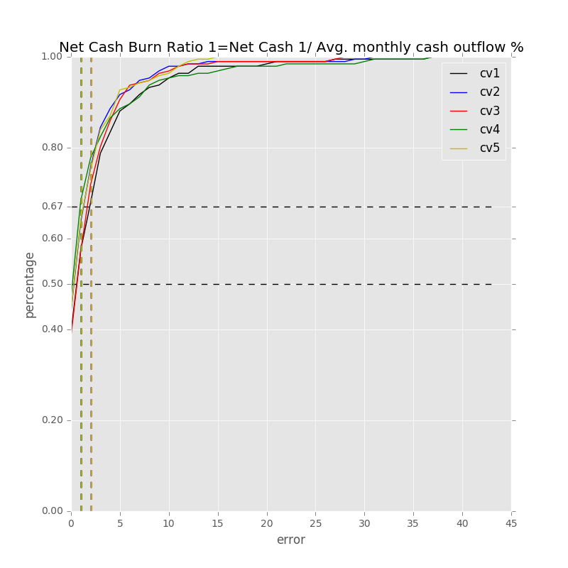

Label: Net Cash Burn Ratio 1=Net Cash 1/ Avg. monthly cash outflow %

Min Error: 0.002123

Mean Error: 2.994661

Median Error: 1.369927

Max Error: 37.473855

Feature importance:

Total Liabilities/Total Assets % : 0.042442

Rev YOY % : 0.037334

Net Income Margin % : 0.036569

Net Property, Plant & Equipment/ Total Assets % : 0.036251

Cash from Ops./Net Income% : 0.035695

Cash from Ops./EBITDA % : 0.035001

Gross Margin % : 0.034380

Avg. Days Sales Out. (Days): 0.034111

Total Asset Turnover : 0.033886

Avg. Days Payable Out. (Days): 0.033797

Total Debt/Equity % : 0.033416

Return on Assets % : 0.032637

EBITDA Margin % : 0.031803

Other Operating Exp. Total ($USDmm, Current rate): 0.031771

Capital Expenditure ($USDmm, Current rate): 0.031346

Total Revenue ($USDmm, Current rate): 0.031323

Cost Of Goods Sold ($USDmm, Current rate): 0.029921

R&D Exp./Total Revenue % : 0.029433

Depreciation & Amort., Total ($USDmm, Current rate): 0.029328

EBITDA ($USDmm, Current rate): 0.028970

Total Liabilities ($USDmm, Current rate): 0.028841

Avg. Cash Conversion Cycle (Days): 0.028707

Net Income ($USDmm, Current rate): 0.028542

Cash from Ops. ($USDmm, Current rate): 0.028115

Avg. Days Inventory Out. (Days): 0.027781

Total Assets ($USDmm, Current rate): 0.027743

Return on Equity % : 0.027550

Net Property, Plant & Equipment ($USDmm, Current rate): 0.026005

Year Founded: 0.025687

Number of Employees/Total Revenue [LTM] (Latest): 0.024336

R&D Exp. ($USDmm, Current rate): 0.023031

Payout Ratio (%): 0.020053

Issuer Credit Rating - Foreign Currency LT [Latest] (Rating): 0.014194

Label: Net Cash Burn Ratio 1=Net Cash 1/ Avg. monthly cash outflow %

Min Error: 0.003941

Mean Error: 2.404899

Median Error: 1.269868

Max Error: 31.017464

Feature importance:

Rev YOY % : 0.041615

Cash from Ops./Net Income% : 0.040159

Net Income Margin % : 0.039546

Total Liabilities/Total Assets % : 0.038544

Return on Assets % : 0.037066

Avg. Days Payable Out. (Days): 0.036253

Cash from Ops./EBITDA % : 0.035947

Total Debt/Equity % : 0.035276

Net Property, Plant & Equipment/ Total Assets % : 0.034424

Total Liabilities ($USDmm, Current rate): 0.033717

Total Asset Turnover : 0.033426

Avg. Days Sales Out. (Days): 0.033059

Other Operating Exp. Total ($USDmm, Current rate): 0.032343

EBITDA Margin % : 0.031846

Net Income ($USDmm, Current rate): 0.031101

Gross Margin % : 0.030590

Avg. Cash Conversion Cycle (Days): 0.030531

R&D Exp./Total Revenue % : 0.030025

Cost Of Goods Sold ($USDmm, Current rate): 0.029147

Capital Expenditure ($USDmm, Current rate): 0.029112

Return on Equity % : 0.028659

Total Revenue ($USDmm, Current rate): 0.028205

Net Property, Plant & Equipment ($USDmm, Current rate): 0.028142

Total Assets ($USDmm, Current rate): 0.028084

Cash from Ops. ($USDmm, Current rate): 0.027931

Depreciation & Amort., Total ($USDmm, Current rate): 0.027087

EBITDA ($USDmm, Current rate): 0.027049

Avg. Days Inventory Out. (Days): 0.024365

Year Founded: 0.024329

Payout Ratio (%): 0.022497

R&D Exp. ($USDmm, Current rate): 0.021980

Number of Employees/Total Revenue [LTM] (Latest): 0.017508

Issuer Credit Rating - Foreign Currency LT [Latest] (Rating): 0.010438

Label: Net Cash Burn Ratio 1=Net Cash 1/ Avg. monthly cash outflow %

Min Error: 0.005085

Mean Error: 2.874535

Median Error: 1.485508

Max Error: 43.499080

Feature importance:

Rev YOY % : 0.040389

Total Liabilities/Total Assets % : 0.039789

Cash from Ops./EBITDA % : 0.039301

Net Income Margin % : 0.037288

Cash from Ops./Net Income% : 0.036534

Total Debt/Equity % : 0.036513

Net Property, Plant & Equipment/ Total Assets % : 0.036083

Avg. Days Payable Out. (Days): 0.035768

EBITDA Margin % : 0.035272

Total Asset Turnover : 0.034531

Return on Equity % : 0.033794

Avg. Days Sales Out. (Days): 0.033602

Return on Assets % : 0.033106

Capital Expenditure ($USDmm, Current rate): 0.031719

Other Operating Exp. Total ($USDmm, Current rate): 0.030627

Avg. Cash Conversion Cycle (Days): 0.030189

EBITDA ($USDmm, Current rate): 0.030078

Net Income ($USDmm, Current rate): 0.029746

Total Liabilities ($USDmm, Current rate): 0.029718

R&D Exp./Total Revenue % : 0.029143

Cost Of Goods Sold ($USDmm, Current rate): 0.028841

Gross Margin % : 0.028035

Total Revenue ($USDmm, Current rate): 0.027791

Depreciation & Amort., Total ($USDmm, Current rate): 0.027397

Avg. Days Inventory Out. (Days): 0.026206

Total Assets ($USDmm, Current rate): 0.025784

Net Property, Plant & Equipment ($USDmm, Current rate): 0.025393

Cash from Ops. ($USDmm, Current rate): 0.025128

Year Founded: 0.024071

R&D Exp. ($USDmm, Current rate): 0.023255

Number of Employees/Total Revenue [LTM] (Latest): 0.021431

Payout Ratio (%): 0.020053

Issuer Credit Rating - Foreign Currency LT [Latest] (Rating): 0.013424

Label: Net Cash Burn Ratio 1=Net Cash 1/ Avg. monthly cash outflow %

Min Error: 0.008494

Mean Error: 2.765590

Median Error: 1.054073

Max Error: 37.198145

Feature importance:

Total Liabilities/Total Assets % : 0.042430

Rev YOY % : 0.042294

Net Income Margin % : 0.039772

Net Property, Plant & Equipment/ Total Assets % : 0.038022

Cash from Ops./Net Income% : 0.036117

Gross Margin % : 0.035305

Cash from Ops./EBITDA % : 0.034975

Avg. Days Payable Out. (Days): 0.034491

EBITDA Margin % : 0.034406

Return on Assets % : 0.034020

Avg. Cash Conversion Cycle (Days): 0.033537

Avg. Days Sales Out. (Days): 0.033001

Total Debt/Equity % : 0.032738

Net Income ($USDmm, Current rate): 0.032698

Capital Expenditure ($USDmm, Current rate): 0.030166

Other Operating Exp. Total ($USDmm, Current rate): 0.029634

Total Revenue ($USDmm, Current rate): 0.029505

Total Assets ($USDmm, Current rate): 0.029422

Total Liabilities ($USDmm, Current rate): 0.029153

Total Asset Turnover : 0.028900

Return on Equity % : 0.028734

Cash from Ops. ($USDmm, Current rate): 0.028375

Avg. Days Inventory Out. (Days): 0.027911

Depreciation & Amort., Total ($USDmm, Current rate): 0.027302

R&D Exp./Total Revenue % : 0.027159

EBITDA ($USDmm, Current rate): 0.026766

Cost Of Goods Sold ($USDmm, Current rate): 0.026342

Net Property, Plant & Equipment ($USDmm, Current rate): 0.024899

R&D Exp. ($USDmm, Current rate): 0.024052

Year Founded: 0.023937

Number of Employees/Total Revenue [LTM] (Latest): 0.021488

Payout Ratio (%): 0.020667

Issuer Credit Rating - Foreign Currency LT [Latest] (Rating): 0.011781

Label: Net Cash Burn Ratio 1=Net Cash 1/ Avg. monthly cash outflow %

Min Error: 0.003369

Mean Error: 2.271713

Median Error: 1.214813

Max Error: 15.086175

Feature importance:

Total Liabilities/Total Assets % : 0.040608

Gross Margin % : 0.038009

Rev YOY % : 0.037956

Net Income Margin % : 0.037517

Avg. Days Sales Out. (Days): 0.036385

Cash from Ops./EBITDA % : 0.034330

Return on Assets % : 0.034293

Cash from Ops./Net Income% : 0.034059

Total Asset Turnover : 0.033895

Avg. Days Payable Out. (Days): 0.033707

Total Debt/Equity % : 0.033134

Net Property, Plant & Equipment/ Total Assets % : 0.033103

Capital Expenditure ($USDmm, Current rate): 0.033068

EBITDA Margin % : 0.033033

Return on Equity % : 0.032572

Avg. Cash Conversion Cycle (Days): 0.031782

Net Income ($USDmm, Current rate): 0.031696

Total Liabilities ($USDmm, Current rate): 0.031015

Total Revenue ($USDmm, Current rate): 0.030089

Cost Of Goods Sold ($USDmm, Current rate): 0.030035

Other Operating Exp. Total ($USDmm, Current rate): 0.029074

R&D Exp./Total Revenue % : 0.028917

Total Assets ($USDmm, Current rate): 0.028741

Depreciation & Amort., Total ($USDmm, Current rate): 0.027954

Net Property, Plant & Equipment ($USDmm, Current rate): 0.027897

EBITDA ($USDmm, Current rate): 0.026442

Cash from Ops. ($USDmm, Current rate): 0.025343

Year Founded: 0.025110

Avg. Days Inventory Out. (Days): 0.024867

R&D Exp. ($USDmm, Current rate): 0.024729

Number of Employees/Total Revenue [LTM] (Latest): 0.020107

Payout Ratio (%): 0.018483

Issuer Credit Rating - Foreign Currency LT [Latest] (Rating): 0.012052

Total Min: 0.004602

Total Mean: 2.662279

Total Median: 1.278838

Total Max: 32.854944

## 模型7

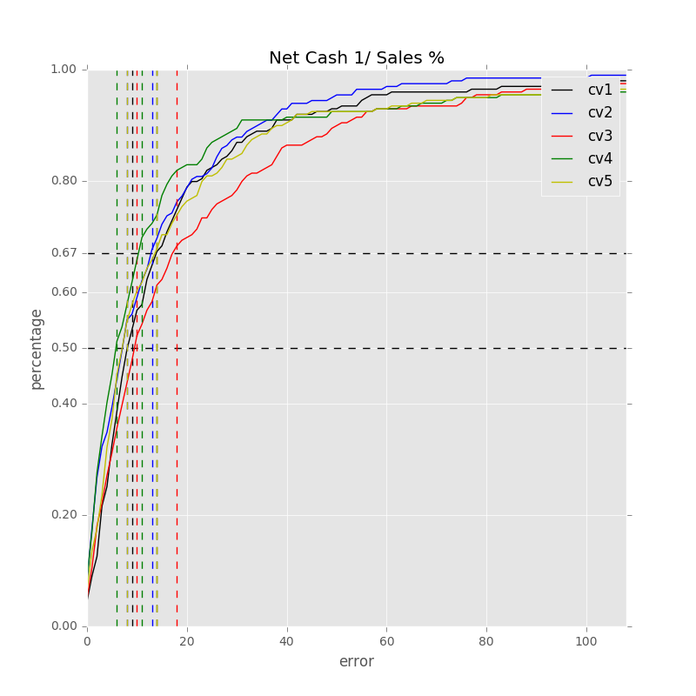

Label: Net Cash 1/ Sales %

Min Error: 0.100726

Mean Error: 19.219985

Median Error: 9.070952

Max Error: 273.345596

Feature importance:

Rev YOY % : 0.042300

Cash from Ops./Net Income% : 0.039122

Total Liabilities/Total Assets % : 0.038040

Net Income Margin % : 0.037067

Total Liabilities ($USDmm, Current rate): 0.035384

Total Revenue ($USDmm, Current rate): 0.034109

Avg. Days Sales Out. (Days): 0.033629

Total Debt/Equity % : 0.033605

Return on Assets % : 0.033589

Total Asset Turnover : 0.033538

Cash from Ops./EBITDA % : 0.033472

Avg. Days Payable Out. (Days): 0.032819

Net Property, Plant & Equipment/ Total Assets % : 0.032637

Capital Expenditure ($USDmm, Current rate): 0.031900

EBITDA Margin % : 0.031679

R&D Exp./Total Revenue % : 0.031655

Gross Margin % : 0.031146

Return on Equity % : 0.030608

Other Operating Exp. Total ($USDmm, Current rate): 0.029922

Net Property, Plant & Equipment ($USDmm, Current rate): 0.029629

Net Income ($USDmm, Current rate): 0.029360

EBITDA ($USDmm, Current rate): 0.029218

Avg. Cash Conversion Cycle (Days): 0.029076

Depreciation & Amort., Total ($USDmm, Current rate): 0.028933

Avg. Days Inventory Out. (Days): 0.028747

Cost Of Goods Sold ($USDmm, Current rate): 0.028043

Total Assets ($USDmm, Current rate): 0.027878

Cash from Ops. ($USDmm, Current rate): 0.025708

R&D Exp. ($USDmm, Current rate): 0.025153

Year Founded: 0.023384

Number of Employees/Total Revenue [LTM] (Latest): 0.019929

Payout Ratio (%): 0.019085

Issuer Credit Rating - Foreign Currency LT [Latest] (Rating): 0.009638

Label: Net Cash 1/ Sales %

Min Error: 0.118793

Mean Error: 47.092806

Median Error: 8.136892

Max Error: 6424.197474

Feature importance:

Total Liabilities/Total Assets % : 0.042606

Rev YOY % : 0.040365

Cash from Ops./Net Income% : 0.037700

Cash from Ops./EBITDA % : 0.037553

Net Property, Plant & Equipment/ Total Assets % : 0.036697

Net Income Margin % : 0.036006

Return on Assets % : 0.034821

Avg. Days Sales Out. (Days): 0.034816

Gross Margin % : 0.034751

Avg. Days Payable Out. (Days): 0.034669

Total Debt/Equity % : 0.033919

EBITDA Margin % : 0.032232

Total Asset Turnover : 0.031894

Total Liabilities ($USDmm, Current rate): 0.030698

Cash from Ops. ($USDmm, Current rate): 0.030673

Other Operating Exp. Total ($USDmm, Current rate): 0.030277

Avg. Cash Conversion Cycle (Days): 0.030099

Cost Of Goods Sold ($USDmm, Current rate): 0.030091

Net Income ($USDmm, Current rate): 0.029246

Total Revenue ($USDmm, Current rate): 0.029133

R&D Exp./Total Revenue % : 0.028950

Capital Expenditure ($USDmm, Current rate): 0.028723

Net Property, Plant & Equipment ($USDmm, Current rate): 0.028331

Return on Equity % : 0.028146

EBITDA ($USDmm, Current rate): 0.027893

Avg. Days Inventory Out. (Days): 0.027628

Total Assets ($USDmm, Current rate): 0.026545

Depreciation & Amort., Total ($USDmm, Current rate): 0.025141

Year Founded: 0.023933

R&D Exp. ($USDmm, Current rate): 0.023773

Number of Employees/Total Revenue [LTM] (Latest): 0.023065

Payout Ratio (%): 0.018802

Issuer Credit Rating - Foreign Currency LT [Latest] (Rating): 0.010826

Label: Net Cash 1/ Sales %

Min Error: 0.049768

Mean Error: 27.715146

Median Error: 10.293940

Max Error: 770.623786

Feature importance:

Total Liabilities/Total Assets % : 0.044625

Rev YOY % : 0.039061

Net Property, Plant & Equipment/ Total Assets % : 0.038749

Net Income Margin % : 0.037175

Avg. Days Sales Out. (Days): 0.036281

Return on Assets % : 0.035986

Cash from Ops./EBITDA % : 0.034792

Avg. Cash Conversion Cycle (Days): 0.034408

Gross Margin % : 0.034269

Total Debt/Equity % : 0.033284

Cash from Ops./Net Income% : 0.032289

Other Operating Exp. Total ($USDmm, Current rate): 0.032232

EBITDA ($USDmm, Current rate): 0.032007

Total Asset Turnover : 0.031358

EBITDA Margin % : 0.031188

Avg. Days Payable Out. (Days): 0.030777

R&D Exp./Total Revenue % : 0.030161

Total Liabilities ($USDmm, Current rate): 0.029470

Total Revenue ($USDmm, Current rate): 0.029359

Cost Of Goods Sold ($USDmm, Current rate): 0.029041

Net Income ($USDmm, Current rate): 0.028791

Capital Expenditure ($USDmm, Current rate): 0.028701

Cash from Ops. ($USDmm, Current rate): 0.027658

Year Founded: 0.026812

Depreciation & Amort., Total ($USDmm, Current rate): 0.026768

Total Assets ($USDmm, Current rate): 0.026580

Return on Equity % : 0.025760

Number of Employees/Total Revenue [LTM] (Latest): 0.025462

Avg. Days Inventory Out. (Days): 0.025314

Net Property, Plant & Equipment ($USDmm, Current rate): 0.024581

R&D Exp. ($USDmm, Current rate): 0.024008

Payout Ratio (%): 0.020979

Issuer Credit Rating - Foreign Currency LT [Latest] (Rating): 0.012072

Label: Net Cash 1/ Sales %

Min Error: 0.079987

Mean Error: 20.182959

Median Error: 6.761100

Max Error: 527.428911

Feature importance:

Total Liabilities/Total Assets % : 0.043122

Rev YOY % : 0.038981

Cash from Ops./Net Income% : 0.037697

Net Income Margin % : 0.036297

Cash from Ops./EBITDA % : 0.035250

Net Property, Plant & Equipment/ Total Assets % : 0.034473

Avg. Days Sales Out. (Days): 0.034310

Total Asset Turnover : 0.034137

Total Debt/Equity % : 0.033442

EBITDA Margin % : 0.033254

Return on Assets % : 0.033023

Cost Of Goods Sold ($USDmm, Current rate): 0.032589

Total Liabilities ($USDmm, Current rate): 0.032036

Avg. Days Payable Out. (Days): 0.031679

Avg. Cash Conversion Cycle (Days): 0.031175

Total Revenue ($USDmm, Current rate): 0.031143

Return on Equity % : 0.031038

Other Operating Exp. Total ($USDmm, Current rate): 0.030506

R&D Exp./Total Revenue % : 0.030458

Gross Margin % : 0.030366

EBITDA ($USDmm, Current rate): 0.029679

Net Income ($USDmm, Current rate): 0.029398

Cash from Ops. ($USDmm, Current rate): 0.029206

Capital Expenditure ($USDmm, Current rate): 0.028756

Avg. Days Inventory Out. (Days): 0.027975

Depreciation & Amort., Total ($USDmm, Current rate): 0.027684

Net Property, Plant & Equipment ($USDmm, Current rate): 0.027481

Total Assets ($USDmm, Current rate): 0.025795

Year Founded: 0.023312

R&D Exp. ($USDmm, Current rate): 0.022440

Number of Employees/Total Revenue [LTM] (Latest): 0.020868

Payout Ratio (%): 0.018656

Issuer Credit Rating - Foreign Currency LT [Latest] (Rating): 0.013773

Label: Net Cash 1/ Sales %

Min Error: 0.020945

Mean Error: 22.676796

Median Error: 8.042449

Max Error: 567.921097

Feature importance:

Rev YOY % : 0.041769

Total Liabilities/Total Assets % : 0.040200

Cash from Ops./EBITDA % : 0.038320

Cash from Ops./Net Income% : 0.036448

Total Debt/Equity % : 0.035216

Net Property, Plant & Equipment/ Total Assets % : 0.035142

Avg. Cash Conversion Cycle (Days): 0.034821

Net Income Margin % : 0.034785

Avg. Days Sales Out. (Days): 0.033787

Gross Margin % : 0.033721

EBITDA Margin % : 0.033703

R&D Exp./Total Revenue % : 0.033374

Return on Assets % : 0.032955

EBITDA ($USDmm, Current rate): 0.032404

Total Revenue ($USDmm, Current rate): 0.031490

Total Liabilities ($USDmm, Current rate): 0.031176

Capital Expenditure ($USDmm, Current rate): 0.031062

Total Asset Turnover : 0.030152

Cost Of Goods Sold ($USDmm, Current rate): 0.029075

Avg. Days Payable Out. (Days): 0.028955

Net Income ($USDmm, Current rate): 0.028896

Return on Equity % : 0.028776

Net Property, Plant & Equipment ($USDmm, Current rate): 0.028761

Other Operating Exp. Total ($USDmm, Current rate): 0.028256

Total Assets ($USDmm, Current rate): 0.026676

Depreciation & Amort., Total ($USDmm, Current rate): 0.026118

Avg. Days Inventory Out. (Days): 0.025972

Cash from Ops. ($USDmm, Current rate): 0.025738

Number of Employees/Total Revenue [LTM] (Latest): 0.023133

R&D Exp. ($USDmm, Current rate): 0.023118

Payout Ratio (%): 0.022143

Year Founded: 0.021803

Issuer Credit Rating - Foreign Currency LT [Latest] (Rating): 0.012057

Total Min: 0.074044

Total Mean: 27.377538

Total Median: 8.461067

Total Max: 1712.703373